


Report Of First Quarter 2015

Ministry Of Pastor Isaac Peter Oyako

Apostle Paul wrote his second letter to the Church of Thessalonica to address the panic which was in the church, that the day of the Lord had come, and many believed they might have actually been in the 'day of the Lord' because of the terrible time of persecution.

This seeds of false doctrine had been planted by the false teachers, and many were already discouraged and had developed a sluggish lifestyle. The Apostle Paul wrote this letter as an encouragement, to correct the wrong doctrine on rapture and the day of the Lord, rebuke the perverted attitudes

that you not be quickly shaken from your composure or be disturbed either by a spirit or a message or a letter as if from us, to the effect that the day of the Lord has come. Let no one in any way deceive you, for it will not come unless the apostasy comes first, and the man of lawlessness is revealed, the son of destruction. who opposes and exalts himself above every so-called god or object of worship, so that he takes his seat in the temple of God, displaying himself as being God. Do you not remember that while I was still with you, I was telling you these things?

And you know what restrains him now, so that in his time he will be revealed.

For the mystery of lawlessness is already at work; only he who now restrains will do so until he is taken out of the way. Then that lawless one will be revealed whom the Lord will slay with the breath of His mouth and bring to an end by the appearance of His coming; that is, the one whose coming is in accord with the activity of Satan, with all power and signs and false wonders, and with all the deception of wickedness for those who perish, because they did not receive the love of the truth so as to be saved. For this reason God will send upon them a deluding influence so that they will believe what is false, in order that they all may be judged who did not believe the truth, but took pleasure in wickedness” (2Thessalonians 2:1-13 NASB)

Today, any one can be tempted to, not only believe that we are closer to rapture, but we are in the tribulation period. Personally, I do not believe we are in tribulation period yet, but quite close to the beginning of Daniel’s 70th week.

The church should seriously be preparing to welcome the departed saints, and join together in meeting the Lord Jesus Christ in the clouds. The intensified challenges: Heightened persecution of Christians in the Muslim world, global economic turn down, escalation of crime, blatant corruption, sexual abuse etc., are nothing but a wake-up call.

There is an urgency in rising up to dress the bride, prepare her cosmetics and perfumes for a grand wedding to take place in sky soon. Every minister of the gospel in their respective calling, gifting and anointing should rise up to the challenge rather than bask in the leadership glory for the sake of it.

The first quarter of year 2015, has been generally an uphill journey for us in Revival Time Ministry-Uganda, and me in particular. I have faced formidable forces of resistance and contrary winds, but as they word says, “From the days of John the Baptist, the kingdom faces violence, and the violent take it by faith.”

Ministry of Counseling by Pastor Isaac

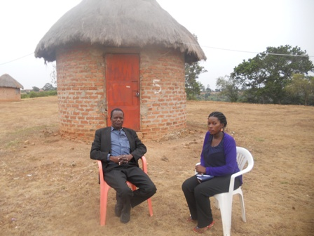
Today I look back, with humility, satisfaction and gratitude to the Lord for His Grace who enabled me to be a blessing to many different categories of people this quarter. The Lord did it all; I am merely a vessel surviving by Grace and energized by the Holy Spirit who, not only sealed me for eternal benefit, but helps me daily.

I was privileged to ministry to hundreds of people on the very first day of this year. The Church could not contain the number people who had come for the overnight prayer and first day of the year in Bugembe Miracle Center Church.

Pastor Isaac Peter Oyako during Valentine weekend
with Medical Student at Kako Hill-Masaka
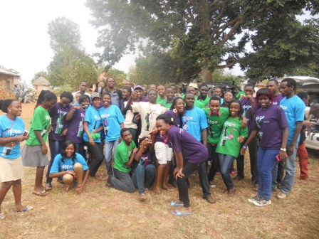
I was privileged to be specially select-ed by Mbarara University Medical School students to spend valentine weekend in Kako Hill camp with them discussing issues to do with purity, relationship and courtship.

Not only did I teach, but had special time with a few in personal counsel-ing. Our office in Jinja has been busy with counselees coming all the way from different parts of the country.

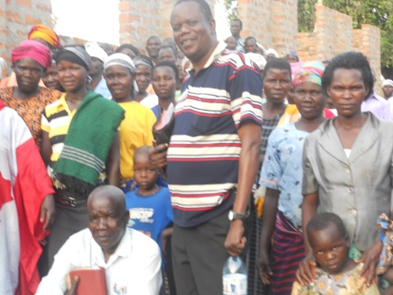

I had the opportunity to hold seminars with upcountry leaders of my local church, Faith Mission Uganda. In every place, God’s hand has been me, touching people and healing them emotionally too.

Pastor Isaac P Oyako at General Church
Seminar in Amuria Faith Mission Church
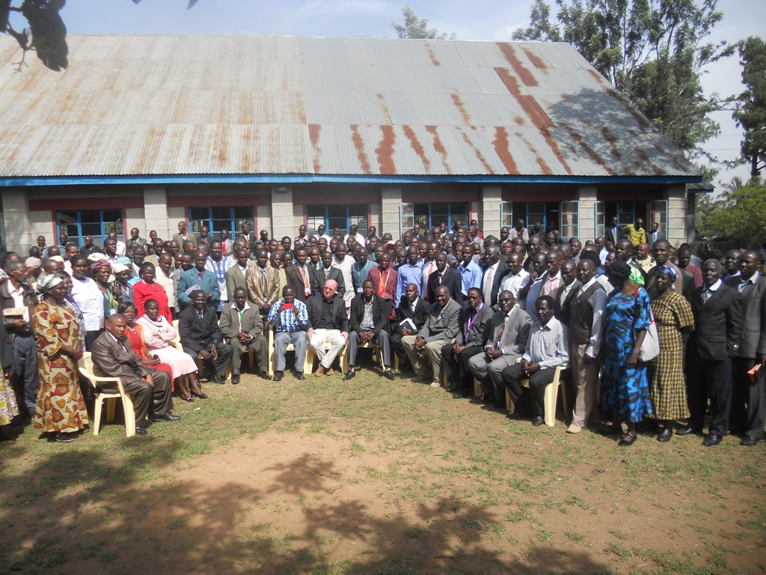

I was blessed to be invited to minister to church leaders in the neighboring country, Kenya. It was a new opening for me.

By God’s Grace and favor, I have been invited to speak in the women conference in Kenya. Over 1,000 women are expected to attend.

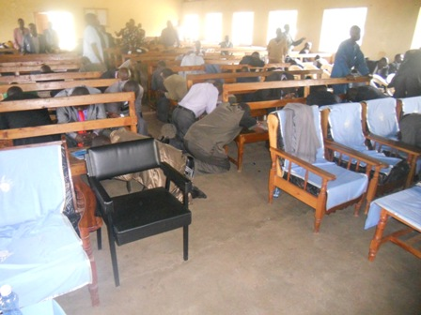
Church leaders attendance in Kenya

It is a well of opportunities to minister. At the beginning of this year, I officiated a very high profile marriage. In the attendance, were some of the dignitaries of my Country.

Revival During the meeting in Kenya

Some of this has come up to me as a surprise really. I thought I would not be able to do anything this quarter. I had taken a tough decision to retire from formal leadership position in my local church. I wanted to seek the Lord for a fresh direction in ministry. It is amazing that I did find time to put my knee down and the doors are bursting open by themselves.

Prayer Points:

As stated previously, this journey had been a steep climb, not only for ministry, but RTM staff and my family.

  - Administration: We urgently need a desktop computer. Our two desktops computers crashed the same day. There was a deadly virus in the memory stick. Rose, the secretary had been trying to print out work from another computer in town acquiring a virus. We also need a scan machine and a photocopier.
  - We are praying for regular support for Rose Nakilima, our Secretary/Bookkeeper. An equivalent of USD $140 a month can sustain Rose.
  - I need funds to print my new book. There are orders for my two books in Kenya and many places in Uganda
  - I am invited for my graduation in Florida-USA in May 30th 2015. I got my Degree transcript, and there is a formal wearing of gowns. I need the finances for that trip.
  - God’s provision for ministry in the next quarter April-June 2015
  - Fees for Joash, our last child with mild disability. He needs up to USD $1400 to finish this year in a special school in Kampala
  - My wife and I are making 25 years in happy marriage, we need to celebrate and thank God

Thank you very much. We welcome any financial, morale and any kind of support. We can be accessed by Western Union, MoneyGram, Bank accounts and online contribution.

Pastor Isaac Peter Oyako
Exec. Supervisor Revival Time Ministry
www.revival-time-ministry.info

Pastor Isaac Peter Oyako

